**Assignment 16.1**

Given a list of numbers - List [Int] (1, 2, 3, 4, 5, 6, 7, 8, 9, 10)

1. Find the sum of all numbers

Sol:

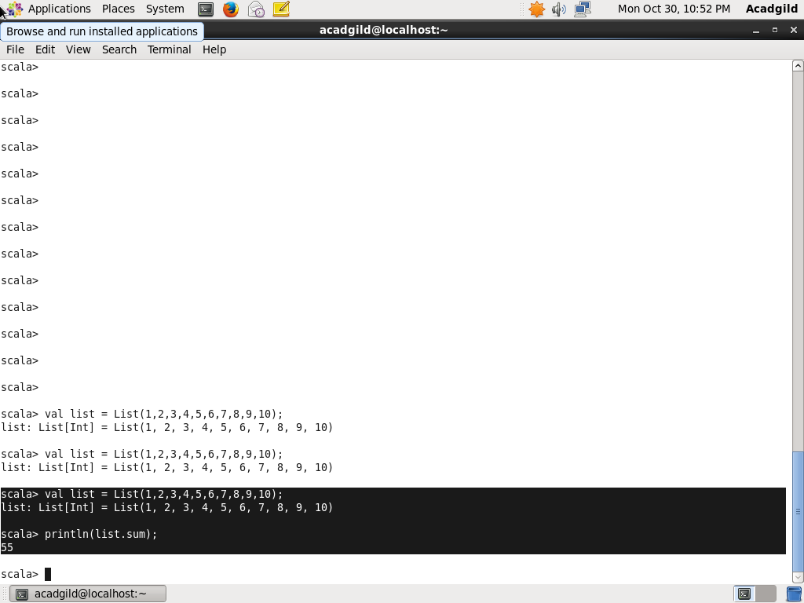

1. Find the total elements in the list

Sol:

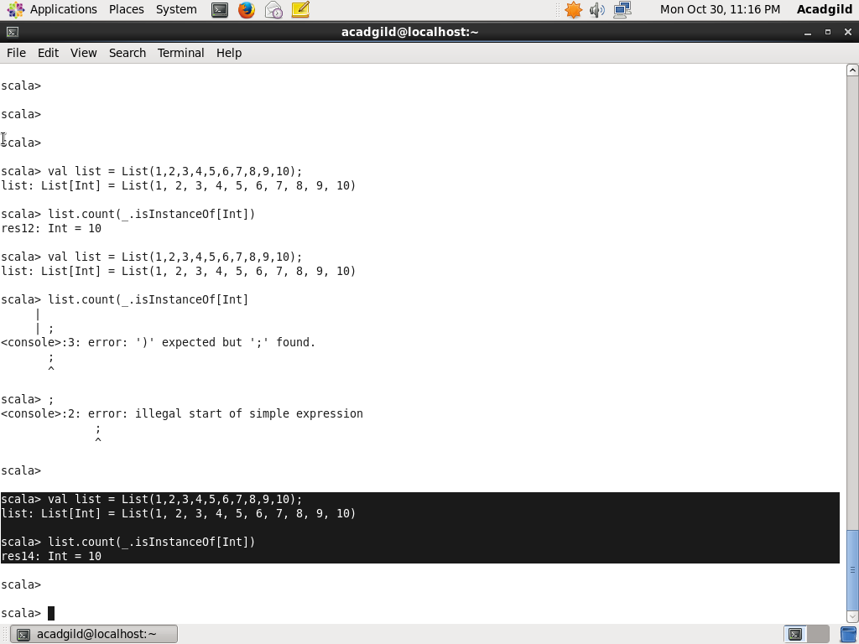

1. Calculate the average of the numbers in the list

Sol:

Avg=sum/Totallength

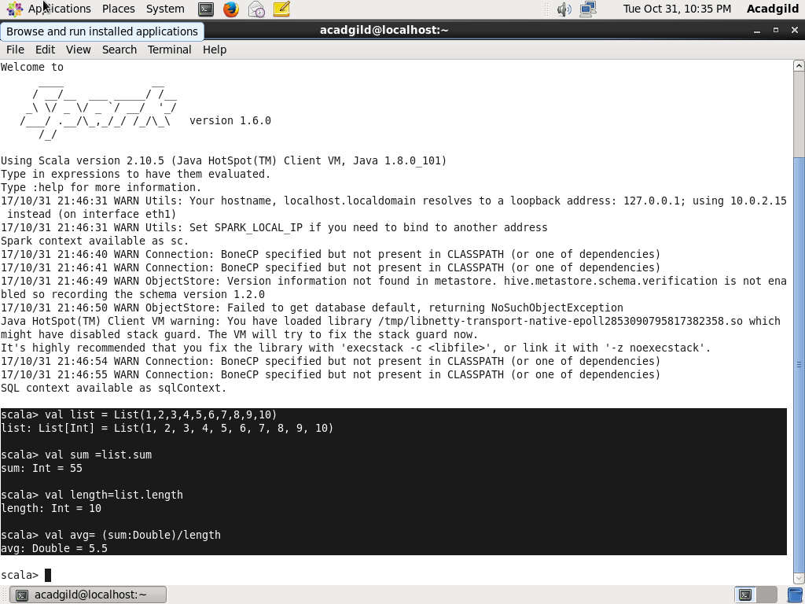

1. Find the sum of all the even numbers in the list

Sol:

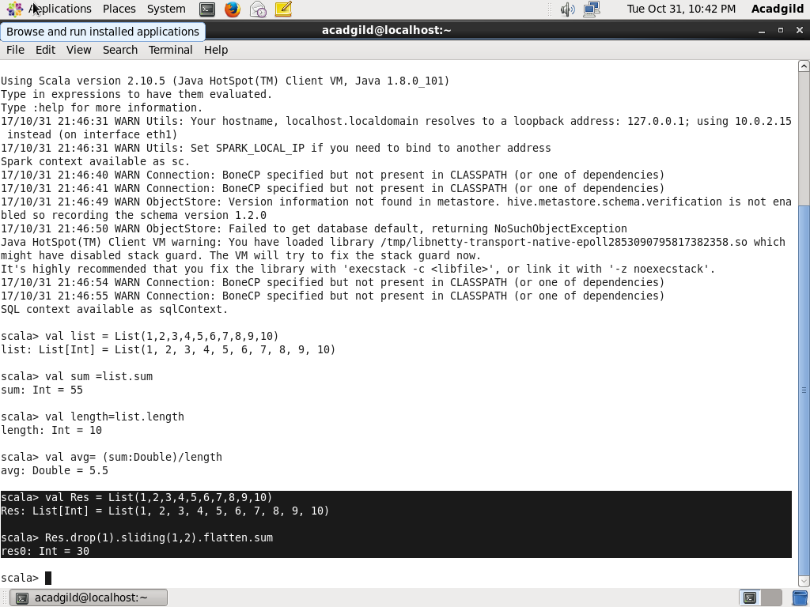

1. Find the total number of elements in the list divisible by both 5 and 3

Sol:

